Building your “Newron”

Instructions: Your objective in this activity is to design a cell capable of carrying out the various functions of the nervous system. Call this cell a “Newron.” You may already know something about neurons, the actual building blocks of the nervous system, but your task is to design a similar cell from scratch. Answer the following questions using both words and diagrams where appropriate. Take no more than 25-30 minutes to answer the questions and sketch your Newron.

- Think about what sorts of information an animal’s nervous system needs to convey to ensure the short-term fitness (e.g., responding appropriately to environmental stimuli) and long-term fitness (e.g., reproducing) of that animal. For example, every animal needs to process sensory information about its environment, whether visual, auditory, tactile, etc. List several other forms of vital information carried by the nervous system of the animal you have in mind.

Responding to danger
Sensory information to mate with others
Sensing a bad smell like rotten eggs
Sensory information to be sensitive to environmental changes such as increase in temperature and coldness.

- Like any other body system, the nervous system is made up of many cells. Given the list of possible functions of the nervous system identified in Question 1, think about what your Newron might look like as the dominant cell type in the nervous system. Describe and/or draw the anatomy of a Newron below, focusing on cellular shape and composition. (Assume that the Newron has the same basic organelles as any animal cell.)

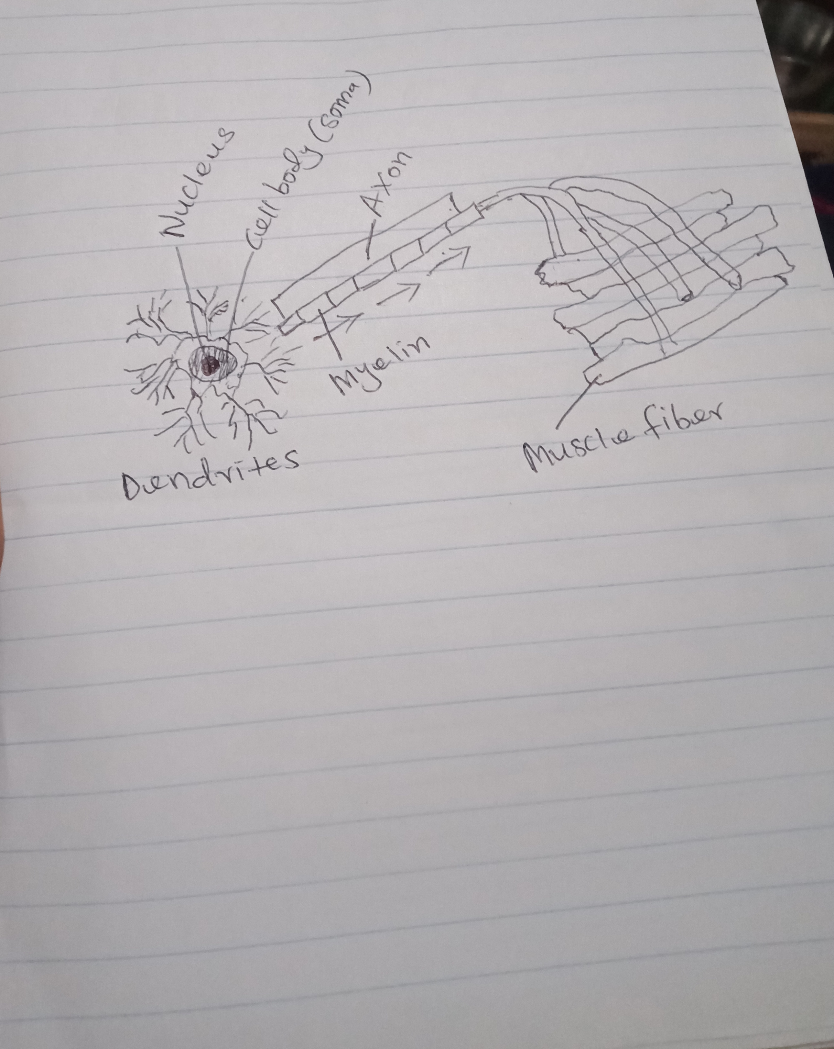
Like other nerve cells, my Newron will consist of a cell body (soma), a single axon, and multiple dendrites. My newron is a motor (efferent) one which means that it will carry impulses away from the central nervous system to the muscles that they control. The axon carries signals from the cell body to other neurons while dendrites receive signals from other neurons. The cell body is responsible for generating energy.
- By their very nature, cells within the nervous system need to communicate with one another, often rapidly. Through what method(s) of communication do Newrons interact? Think about how neurons behave and interact in order to send messages. Perhaps you can borrow something from how they function 😊
Neurons interact or communicate with each other through chemical neurotransmitters and electrical events called action potentials. An action potential takes place at the synapse whereby chemical neurotransmitters are released. Neurotransmitters can either hinder or help neuron B from firing its action potential when neuron A has released a chemical neurotransmitter.

- Given the number of different functions performed by the nervous system, Newrons need to come in different varieties. What sort of varieties exist among Newrons? Think about the different varieties of neurons.
There are three types of neurons: motor, sensory and interneurons. Sensory neurons detect external stimuli and convert it into information that can be processed by the rest of the nervous system. They help one to smell, taste, hear, see and feel things around. Motor neurons are responsible for voluntary and involuntary movement. They facilitate the communication between the brain and spinal cord with muscles and body glands. Motor newrons are further divided into upper and lower motor neurons. Finally, interneurons are neural intermediaries and are the commonest types of neurons. They are found in the brain and spinal cord. They are responsible for passing signals from sensory neurons to motor and other interneurons.

- All cells possess some degree of mechanical flexibility and potential for self-repair in the event of externally induced injury. What sort of protection and repair mechanisms exist in your Newrons?

The newron is surrounded by neuroglia or support cells which protect the newron from foreign invaders and help stabilize the position of the newron. The support cells also help repair (regenerate) damaged newrons. Again, the support cells help in regulating the chemical environment around the newron.

- Looking through your answers to Questions 1-5, proceed to make a sketch of your Newron, labeling all important features. Use the materials provided.
Evaluate Your Newron
Instructions: In the chart below, draw 3-4 comparisons between the Newron you designed and an actual neuron, in terms of structure, mode(s) of communication, cellular varieties, and mechanisms of protection and repair. Hand in this page with your completed newron sketch.

 | Your Newron | Actual Neuron
Structure | My newron consists of a cell body (soma), a single axon, and multiple dendrites | A typical neuron has three basic parts. These are a cell body, a single axon and numerous dendrites. Other parts include the nucleus and myelin sheath.
Communication | My newron communicates via synapses and action potential. | Actual neurons communicate through action potential.
Varieties | Upper and lower newrons | There are three types of neurons: sensory, motor, and interneurons.
Protection and Repair | My newron is surrounded by support cells which protect it from invaders and repair damaged newron. | Typically, neurons are surrounded by support cells also called neuroglia which protect them from foreign invaders, stabilize their position and repair (regenerate) damaged neurons.

